# Lab: AJAX & jQuery AJAX

Problems for in-class lab for the [“JavaScript Applications” course @ SoftUni](https://softuni.bg/courses/javascript-applications). Submit your solutions in the SoftUni judge system at <https://judge.softuni.bg/Contests/Compete/Index/357>.

## XHR (XmlHttpRequest)

Your task is to **write** a JS function that **loads** a github repository **asynchronously with AJAX**. You should **create** an instance of **XmlHttpRequest** an attach an **onreadystatechange** event to it. (An EventHandler that is called whenever the readyState attribute changes). In your event handler when the **readyState** attribute reaches a value of **4** (it is ready), replcae the text content of a **div** element with **id "res"** with the value of the **responseText** property of the request. **Do not format** the response in any way. Submit your loadRepos function.

[More on XmlHttpRequest.open()](https://developer.mozilla.org/en-US/docs/Web/API/XMLHttpRequest/open)

### Skeleton

|  |
| --- |
| **xmlhttprequest-example.html** |
| <!DOCTYPE html>  <html lang="en">  <head>  <meta charset="UTF-8">  <title>XmlHttpRequest Example</title>  <script src="scripts/1.xhr.js"></script>  </head>  <body>  <button onclick="loadRepos()">Load Repos</button>  <div id="res"></div>  <script>  function loadRepos() {  *// TODO*  }  </script>  </body>  </html> |

### Examples

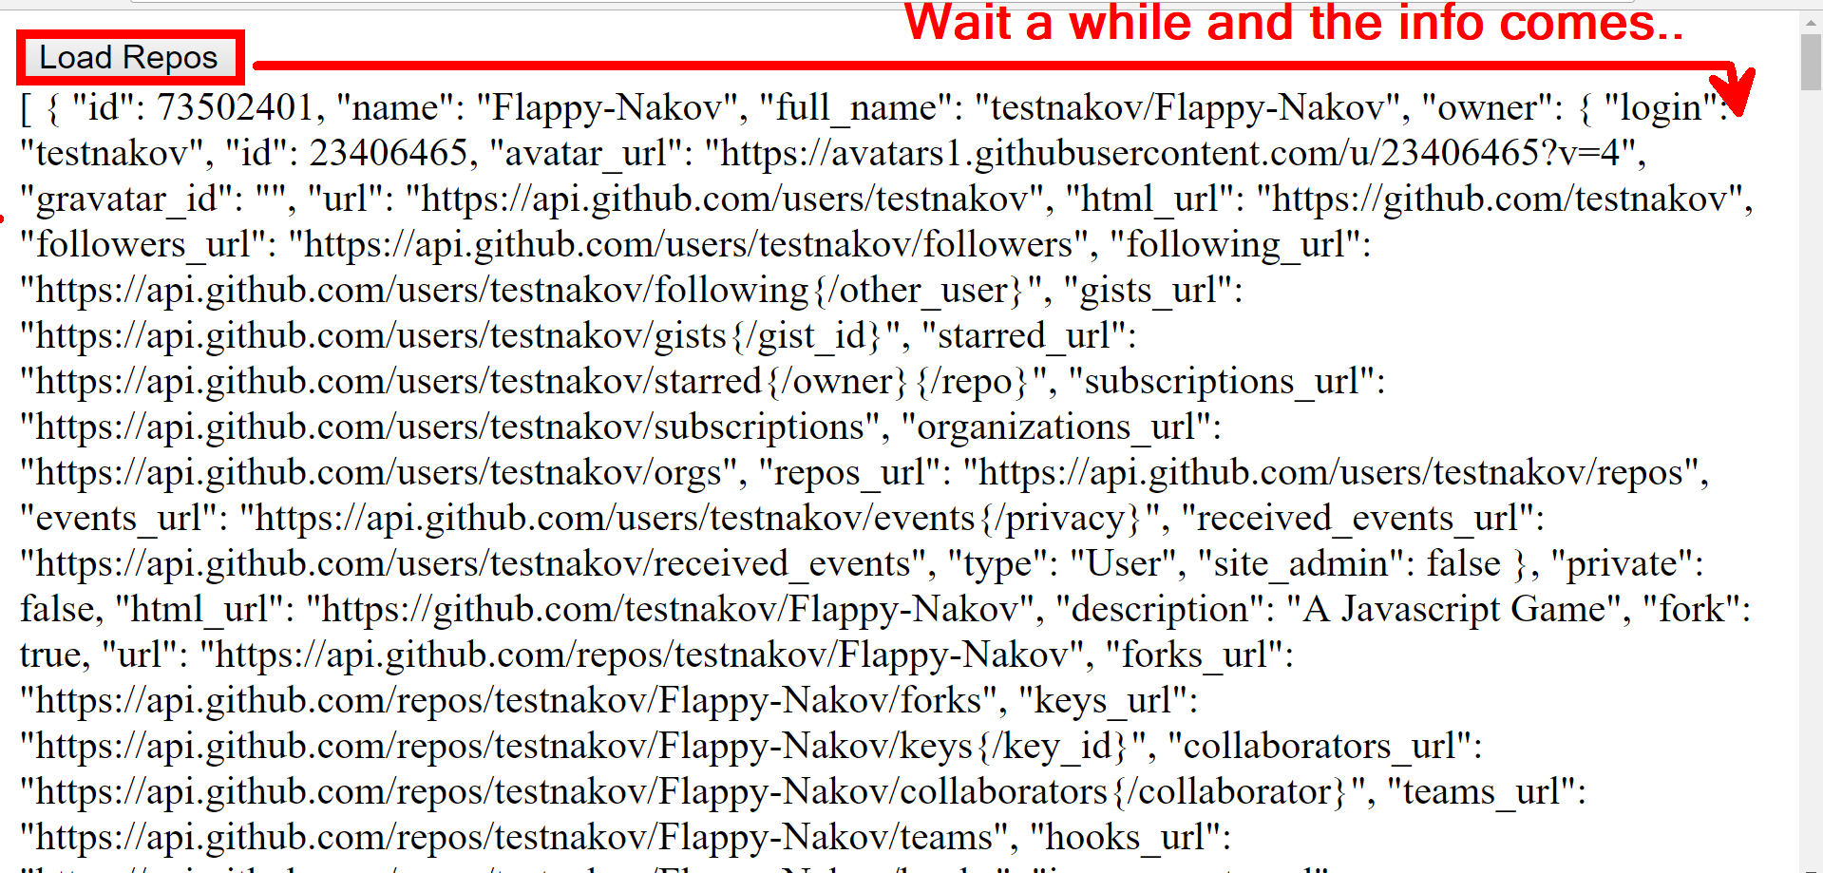

## AJAX Load

Use **jQuery** to **write** a JS function that loads an online resource into a div with **id "text".** Make a request to "**text.html**" and replace the target div’s content with the returned **HTML**. Create the files ajax-load.html and text.html and place them in the same folder, so that your script can find the latter.

Submit your loadTitle function.

### Skeleton

|  |
| --- |
| **ajax-load.html** |
| <!DOCTYPE html>  <html lang="en">  <head>  <meta charset="UTF-8">  <title>AJAX Load Example</title>  <script src="https://code.jquery.com/jquery-3.1.1.min.js"></script>  </head>  <body>  <div id="text">  <h1>AJAX jQuery.load()</h1>  <button onclick="loadTitle()">Load Title</button>  </div>  </body>  </html> |

|  |
| --- |
| **text.html** |
| <h1>Voilla!</h1>  <p>I am a text loaded with AJAX request</p> |

|  |
| --- |
| **ajax-load.js** |
| function loadTitle() {  *// TODO*  } |

### Examples

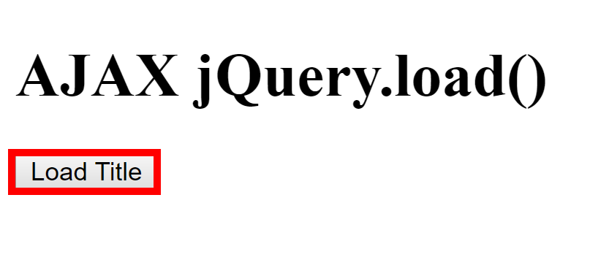 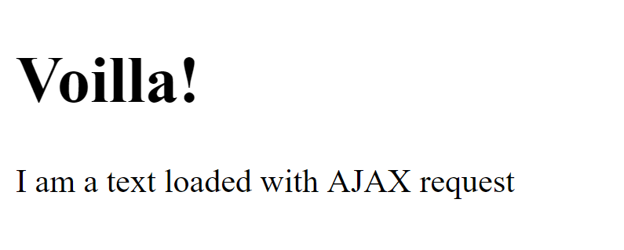

## Github Repos

Your task is to **write** a JS function that **executes** an **AJAX** request with **jQuery** and loads all user **github repositories** by a given username (taken from input field with **id "username"**) into a **list** (each repository as a **list-item**) with **id** "**repos**". Use the properties full_name and html_url of the returned objects to create a link to each repo’s GitHub page. If an **error** occurs (like 404 “Not Found”), **append** to the list a list-item with **text** "Error" instead. Clear the contents of the list before any new content is appended. See the **highlighted lines** of the skeleton for formatting details of each list item. Submit your loadRepos function.

### Skeleton

|  |
| --- |
| **github-repos.html** |
| <!DOCTYPE html>  <html lang="en">  <head>  <meta charset="UTF-8">  <title>GitHub Repos</title>  <script src="https://code.jquery.com/jquery-3.1.1.min.js"></script>  </head>  <body>  GitHub username:  <input type="text" id="username" value="k1r1L" />  <button onclick="loadRepos()">Load Repos</button>  <ul id="repos">  <li>  <a href="*{repo.html_url}*">  *{repo.full_name}*  </a>  </li>  </ul>  <script>  function loadRepos() {  *// AJAX call …*  }  </script>  </body>  </html> |

### Examples

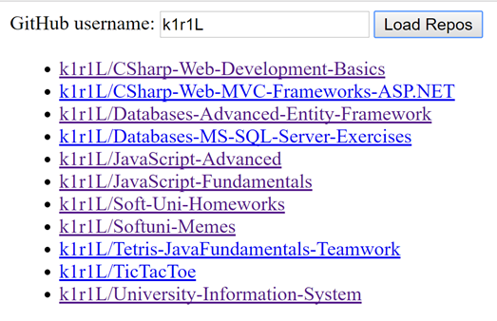

## Phonebook

Use **Firebase** and **jQuery** to create a simple phonebook app. The user should be able to see all contacts, **loaded** from the server, **create** a new contact and **delete** any of the contacts. Use the lecture presentation for detailed instructions on this task. Place your code in a file called "phonebook.js", as shown in the skeleton. This task is not evaluated by the Judge, it is for practice only.

### Skeleton

|  |
| --- |
| **github-repos.html** |
| <!DOCTYPE html>  <html lang="en">  <head>  <meta charset="UTF-8">  <title>Phonebook</title>  </head>  <body>  <h1>Phonebook</h1>  <ul id="phonebook"></ul>  <button id="btnLoad">Load</button>  <h2>Create Contact</h2>  Person: <input type="text" id="person" />  <br>  Phone: <input type="text" id="phone" />  <br>  <button id="btnCreate">Create</button>  <script src="phonebook.js"></script>  </body>  </html> |

### Examples

